Frame of reference: Simulation Date is December 1, 2020
Assume I've replied to your last email and am OK with the RC model end date. You now need to finalize your project scope and submit for "sign off" so the project may begin. The MS Project baseline is your final project plan.
Also, as your boss, I want a risk management assessment. Provide a summary of key risk management issues by creating a risk assessment form (Figure 7.6) and risk response matrix (Figure 7.8). This will require you to role play and use your imagination. There are templates at the end of these instructions.

Procedure
- Finalize the project file by fixing any POM 2 RC feedback; you must start with a correct RC model.
- Using the (correct) POM 2 RC model, create a "POM3 baseline."
- Using the baseline project information, create a (final) Project Scope statement
- Create a Risk Management Plan using templates on page 3 of these instructions
  - Risk Assessment: like Figure 7.6, page 214: (5) risk events, sorted in rank-order
  - Risk Response: like Figure 7.8, page 220: (3) events analyzed. The last column should list an appropriate department manager, i.e. Engineering Manager.
- Create a Word document containing, in order (each starting at the top of a new page)
  - Final scope statement
  - Risk Management plan
  - Tracking Gantt Chart picture with baseline
- Create an email discussing the contents of the baseline and RM plan plus whatever key points you think you need to make. Explain what you need and your next steps as project manager.
  - Consider what you think your boss is most interested in based on the information requested and the project priority matrix in the project introduction.
- Send the email with the Word document attached to angoliam@ecu.edu

Assignment Deliverables
- An email sent to angoliam@ecu.edu
- 2 files submitted to Bb: Word document and MSP file
Technical Requirements
- The scope “deliverables” must be upgraded to complete sentence format for clarity - one deliverable for each bullet and one sentence per deliverable. Milestones, technical requirements and limits/exclusions may be but do not have to be.
- MSP File
  - All POM 2 WBS task formats
  - Baseline set; shown in "tracking” Gantt view with required columns: indicators, tasks, baseline cost, duration, start, finish (all except indicators and tasks are right justified)
- Word documents 11or12 point font only
- Name all files: yourlastname-POM 3 (one will be .docx and the other .mpp)
Limits and Exclusions
- Gantt charts must not show any milestone icons or show resources with the Gantt bars
- Do not include a budget summary or cash flow statement
- Project risk only involves work to complete the project scope and will not consider risk beyond the end of the project; do not include risk regarding ongoing production or profit since your project ends at launch.
- Project risk may not include "over budget" or "finish late"; it must address risk that would cause either of these outcomes
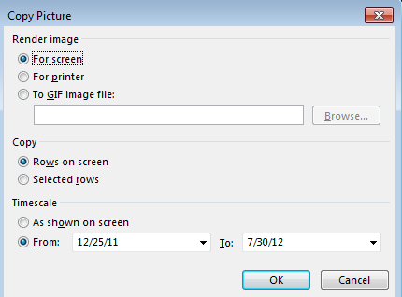
To create more space on the Word doc, use the Page Layout > Breaks > Next Page to increase margins to make the picture text readable; you may need to stretch the picture vertically.
To use MS Project "copy picture" function (adjust year to project year).
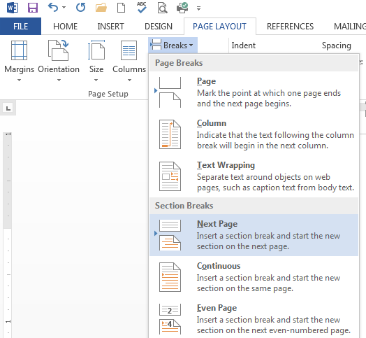
Risk Assessment Table
Rank | Risk Event | Likelihood | Impact | Detection Difficulty | Score
1 | Risk 1
2 | Risk 2
3 | Risk 3
4 | Risk 4
5 | Risk 5

Risk Response Matrix
Score | Risk Event |  | Response |  | Contingency Plan |  | Trigger | Responsible
 | Risk 1
 | Risk 2
 | Risk 3

Solution Image (your project file must match cost, duration, start, finish, and format)
